Drive cycle analysis

**Task:**

**To find the desired torque vs. speed characteristics of a motor to be used in Activa Scooter and battery capacity to be used.**

**Abstract:**

In recent years, EVs are becoming popular due to low carbon footprints, zero tailpipe emission and low NVH levels. India and China are emerging markets for EVs, the low-speed EVs will dominate the market share as congestion on the roads are increasing day by day.

**Introduction:**

In an e-scooter the electric system plays a promising role in its designing and creation. The electric system consists of battery, motor, motor controller and other electronic equipment. The most important thing that electric system does is that it gives power to the motor which helps in the running of the scooter. This energy in form of chemical or electric energy is stored in the battery which is used by a motor, thus the electric or chemical energy converted to mechanical energy.

In India almost 75% share of vehicles in 2019 are 2-wheelers as shown in Fig.1. Every 2-wheeler on a daily average has a trip length of 8-15kms, so if we can replace this vehicle with EV it will bring the emissions level of cities under control limits. In this study we are going to evaluate the different parameter of an EV like motor power, range, battery capacity and energy consumption. For the drive cycle we have done data acquisition using GPS speed graph PLUS from IIT Guwahati to Guwahati city.

So, our main Objectives to evaluate:

1.Motor Power

2.Motor Torque

3.Battery Capacity

4.Range

5.Fuel Consumption of both EV and ICE

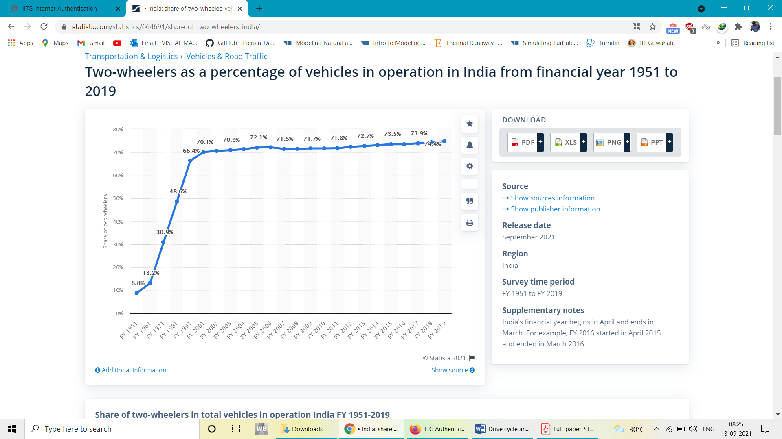

Figure 1- Two-wheelers as a percentage of vehicles in operation in India from financial year 1951 to 2019

**Methodology**

The speed-time data has been recorded between IIT Guwahati and Guwahati city using “GPS speed graph PLUS” on Activa 3G. The recorded data is filtered by a Second order filter (Butterworth) with 0.4 Hz cut off frequency. After the filtering it removes the unwanted spikes present in the data.



The drive cycle then obtained is studied and relevant parameters for alternate electric vehicle option are to be evaluated. The input data in arranged in excel sheet with velocity in kmph.

Plot 1 . Recorded Drive Cycle data for further study

|  |  |  |
| --- | --- | --- |
| **Sr No** | **Parameter** | **Value** |
| **1** | Total mass (Mass of vehicle(kg) + mass of rider(kg)) | 185 |
| **2** | Coefficient of rolling resistance (fr) | 0.004 |
| **3** | Air density (kg/m3) | 1.225 |
| **4** | Aerodynamic drag coefficient of Vehicle (Cd) | 0.6 |
| **5** | Frontal area of vehicle(m2) | 0.8 |
| **6** | Gradient angle, alpha (degree) | 0 |
| **7** | Radius of wheel, r (m) | 0.217 |
| **8** | Gear ratio | 1 |
| **9** | Transmission efficiency | 0.93 |
| **10** | Acceleration due to gravity(m/s2) | 9.81 |

Table 1: The ICE vehicle parameter used for study.

**Calculation of forces acting on a vehicles**

The weight here also includes the weight of rider.

The longitudinal forces to be considered are:

1. **Rolling resistance, Fr**

Rolling resistance, sometimes called rolling friction or rolling drag, is the force resisting the motion when a body rolls on a surface. While other resistances act onIy under certain conditions of motion, rolling resistance is present from the instant the wheels begin to tum. Rolling resistance, in addition, has another undesirable property-a large part of the power expended in a rolling wheel is converted into heat within the tire.

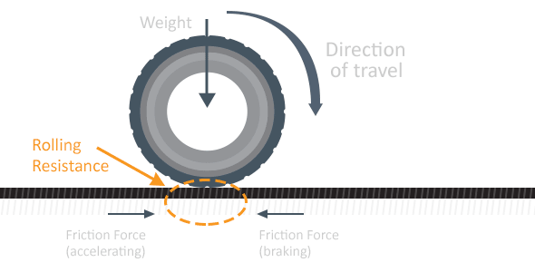

Figure 2: Rolling resistance at wheel

Fr = fr * m * g * cos(alpha)

Since all the values here are constant throughout this force value remains the same.

1. **Aerodynamic Drag, Fd**

A drag force is the resistance force caused by the motion of a body through a fluid. For drag to be generated, the solid body must be in contact with the fluid. If there is no fluid, there is no drag. Drag is generated by difference in velocity between the solid object and the fluid.

Fd = 0.5 * rho * Af * Cd * V^2

Here rho is density of fluid, in our case air density. Af is the frontal area of the vehicle. It depends on shape of the vehicle. It is shown in fig 3 below. Cd is the drag coefficient which is a dimensionless quantity that is used to quantify the drag or resistance of an object in a fluid environment. In general, it is not an absolute constant for a given body shape. It varies with speed of air-flow (Reynolds No).

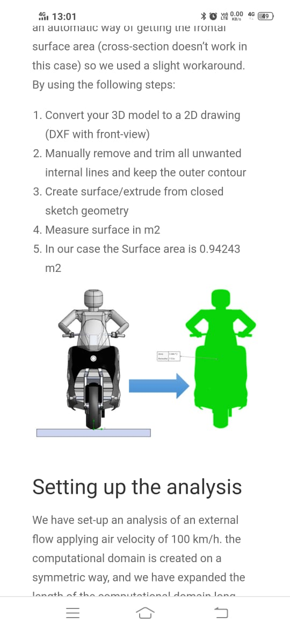

Figure 3: Frontal area

1. **Grading Resistance, Fg**

Gradient resistance of the vehicle is the resistance offered to the vehicle while climbing a hill or flyover or while travelling in a downward slope. The down ward force FST works against the direction of the travel of the vehicle when the vehicle moves upwards on the inclined plane and when driving downhill it works in the direction of the movement of the vehicle. It is proportional to the gross weight of the vehicle and the inclination angle of the inclined plane on which the vehicle is moving.

Fg = m * g * sin(alpha)

Where alpha is angle of inclination

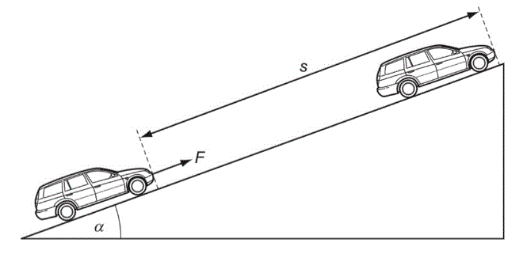

Figure 4: Gradient Resistance

1. **Force due to acceleration, Fa**

When the vehicle moves on acceleration, mass inertia forces arise in the opposite direction of the acceleration. As deceleration is negative acceleration the inertia forces have their effect with the direction of the movement of the vehicle. The proportion of inertia forces in the overall road resistance is called Acceleration resistance.

Fa = m * a

From this at each point the maximum value of force required is estimated and from the speed of vehicle we get the RPM of the wheel. Assuming gear ratio and from the torque obtained from the Total force we get the power required at each point of time.

Plot 2: Power vs Time

The drive data plot of torque vs RPM of all these actual points is,

Plot 3: Drive data (Torque vs RPM)

Now the motor should be such that the torque-speed curve of motor should have least no of points above it when plotted to same scale.

Looking at the power requirement from the power required obtained from drive data we do some iterations to see what motor parameters satisfy above stated condition.

And the points which remain above this line can still be achieved through overloading which is not advised to be done frequently.

|  |  |  |  |
| --- | --- | --- | --- |
| **Iteration** | **Motor Constant power (W)** | **Motor base speed (RPM)** | **Constant torque**  **(Nm)** |
| 1 | 1500 | 300 | 47.74 |
| 2 | 1500 | 400 | 35.80 |
| 3 | 2000 | 300 | 63.66 |

The respective plots of drive data (torque vs RPM)

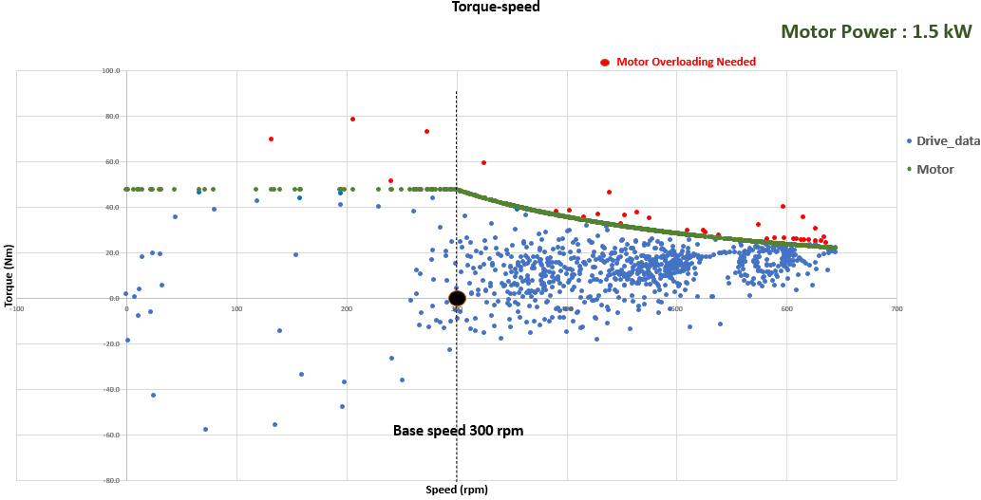

Here as we can see for 1500 W motor with base speed of 300 RPM there are many points above the motor curve which means for these points the motor needs to be overloaded. To see the effects of changing the base speed of a motor the base speed when changed to 400 RPM the results seen are,

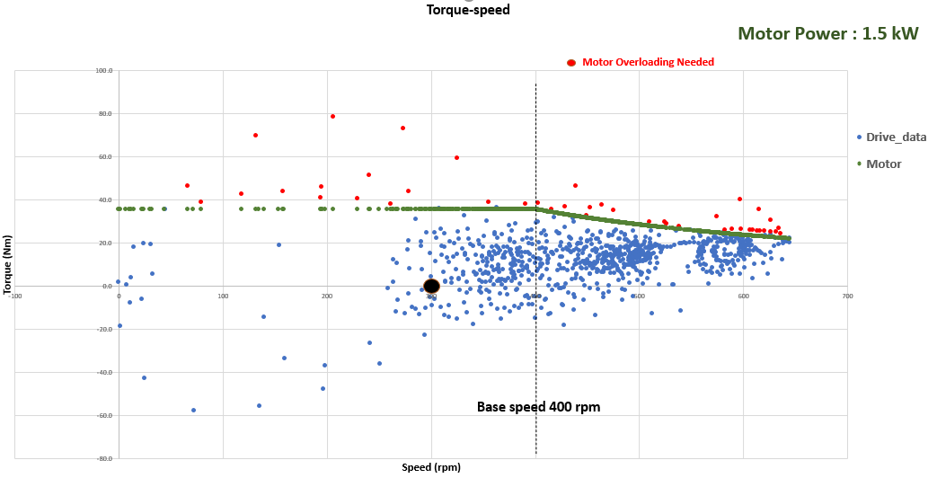

Clearly increasing the base speed is not an option. Increase in motor power to 2000W resulted in better situation as shown in plot below.

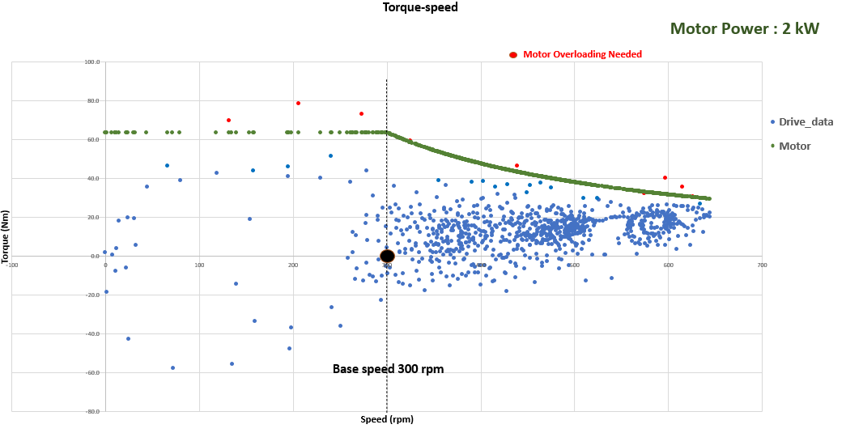

As we can see from above plots, 1.5kW motor with both the speeds leaves several points above its characteristic curve. To minimize these points, let's increase the motor power to 1.8kW and see the effects.

Reference

1. https://www.statista.com/statistics/664691/share-of-two-wheelers-india/